 | PRESS RELEASE  April 25, 2008
Dr. Villoo Morawala-Patell receives ‘Top French Award’
Bangalore, April 25, 2008: The French government bestowed the award of Officier de L’Ordre National du Mérite (Officer of the National Order of Merit) on Dr. Villoo Morawala - Patell, Founder, CMD of AVESTHAGEN LIMITED at a felicitation ceremony in Bangalore on 23 April 2008. The award conferred by H. E. Mr. Nicolas Sarkozy, Hon’ble President of the Republic of France was presented to Dr. Villoo Morawala-Patell by the Ambassador of France to India, Mr. Jerome Bonnafont
Mr. Jerome Bonnafont in his speech expressed:

“As a woman, as a wife -you married 30 years ago-, as a mother of two daughters, as a scientist and ultimately as a businesswoman, in everything you excel.

Beyond your origins, your success must also be attributed to an unconventional temperament, particularly the tenacity of a scientist and businesswoman who has overcome many barriers and incredulity. How many times have you not knocked at the doors of research chairs and private laboratories in India in order to promote a research and business project based on innovation, risk-taking, multidisciplinarity, and a multi-molecular approach? On each occasion, the doors were opened just a crack, and that is why the scientist also became a company manager.

Your passion for and your contribution to France are expressed in the list of prestigious industrial partners who account for the success of your scientific and entrepreneurial talent : Biomérieux, Danone et Limagrain. It is also visible through your unflagging willingness to speak out and share your experience as a start up in the hi-tech world before the members of the French government (last speech in early 2007 during the India visit of the Minister for Industries), French parliamentarians (parliamentary committees and in December 2008 during the economic seminar at the Senate) and company heads who solicit your advice and experience.”

Accepting the award Dr. Patell observed, “France has always been known to recognize Avant-Garde ideas and people and give them a place in their country and in history. The first country to build its foundation on Liberty, equality and fraternity- strong ideals that were beyond their time.

In science too, long ago France gave a home to the world's first systems biologist Leonardo da Vinci who was ahead of his time but largely went unrecognized in his own home country during his lifetime.

Through his studies on living and non-living forms, from architecture to human anatomy, to turbulence of water and the growth patterns of grasses, he pioneered the empirical, systematic approach to the observation of Nature - what is today known as the scientific method.

Francois Premier (François the First) was able to recognize the talent and vision of the man and hosted him as royal guest at the Château Royal d'Amboise where Leonardo spent his last years. Back in the 16th century France was already supporting the coming to life of some of the most striking scientific, technological and artistic master pieces ever created. “

She further observed, “If India has to lead and succeed in this technology, one has to innovate. It requires institutions, governments and dare-devil entrepreneurs to come together and challenge and break existing dogma. Avesthagen has taken in its business model, Indian Biodiversity, disparate, disjointed events, technologies and opportunities and pieced them together to create the next wave of change in bioNutrition, bioPharmaceuticals, bioAgriculture.”

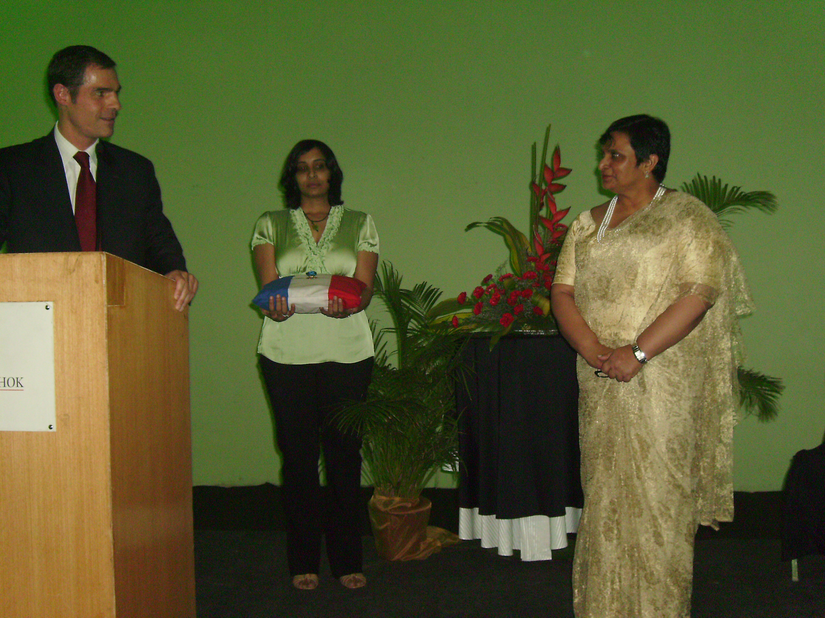
------------------------------------------------------------------------------------------

Avesthagen CMD Dr. Villoo Morawala-Patell was conferred the award of “Officer of National Order of Merit” by Mr. H.E. Jerome Bonnafont the Ambassador of France to India at a felicitation ceremony in Bangalore on April 23, 2008

Media coverage: Hindustan Times, May 17, 2008
About the National Order of Merit
Origin
The National Order of Merit is an Order of Chivalry awarded by the President of the French Republic. It was founded on December 3, 1963 by President Charles de Gaulle.
Ranks
- Grand Cross (grand-croix) – Wears the badge on a sash on the right shoulder, plus the star on the left chest
- Grand Officer (grand officier) – Wears the badge on a ribbon with rosette on the left chest, plus the star on the right chest
- Commander (commandeur) – Wears the badge on a necklet
- Officer (officier) – Wears the badge on a ribbon with rosette on the left chest
- Knight (chevalier) – Wears the badge on a ribbon on the left chest
Description of the insignia
The badge and the plaque of the Order were designed by the French sculptor Max Leognany.

About AVESTHAGEN LIMITED
AVESTHAGEN LIMITED is India’s leading integrated systems biology platform company that focuses on achieving convergence of food, pharma and population genetics leading to predictive preventive and personalized healthcare. It employs 600 people worldwide and is headquartered in Bangalore. AVESTHAGEN LIMITED has established world class, state-of-the-art laboratory facilities in Bangalore. It began business operations in 2001.Since its inception Avesthagen has grown into one of India's leading healthcare technology group in India, and its activities include, in addition to its agri-biotechnologies product pipeline, development of clinically validated botanical bioactives, derived from Indian medicinal plants, as well as the development of a pipeline of bio-similar drugs. AVESTHAGEN LIMITED has four strategic business units: bioPharmaceuticals, bioNutrition, bioAgriculture and Science & Innovation. Its partners include multiple top 10 global companies in each of its fields of research. AVESTHAGEN LIMITED collaborates at every stage in the value chain with appropriate partners, both public and private, for access to and exchange of technology and overall commercial expertise to leverage the ‘India advantage’.

Visit us at: www.avesthagen.com

AVESTHAGEN LIMTED
Anil Chauhan
Vice President – Business Development
Tel: +91-80-2841 1665/2308
Fax: +91-80-2841 8780,
E: anilram@avesthagen.com

Media coverage: Hindustan Times, May 17, 2008

